**LAPORAN PRAKTIKUM**

**PEMROGRAMAN WEB I**

**MODUL 6**



**Bootstrap**

**Oleh:**

**Muhammad Ghazi Rakhmadi NIM.** **2410817310009**

**PROGRAM STUDI TEKNOLOGI INFORMASI**

**FAKULTAS TEKNIK**

**UNIVERSITAS LAMBUNG MANGKURAT**

**JUNI 2025**

# LEMBAR PENGESAHAN

**LAPORAN PRAKTIKUM PEMROGRAMAN WEB I**

**MODUL 6**

Laporan Praktikum Pemrograman Web I Modul 5: Bootstrap ini disusun sebagai syarat lulus mata kuliah Praktikum Pemrograman Web I. Laporan Prakitkum ini dikerjakan oleh:

Nama Praktikan : Muhammad Ghazi Rakhmadi

NIM : 2410817310009

|  |  |
| --- | --- |
| Menyetujui,  Asisten Praktikum  Adrian Bintang Saputera  NIM. 2310817110006 | Mengetahui,  Dosen Penanggung Jawab Praktikum  Muti’a Maulida, S.Kom M.T.I  NIP. 198810272019032013 |

# DAFTAR ISI

LEMBAR PENGESAHAN 1

DAFTAR ISI 2

DAFTAR GAMBAR 3

DAFTAR TABEL 4

SOAL PRAKTIKUM 5

Source Code 6

Output 14

Pembahasan 15

GITHUB 25

# DAFTAR GAMBAR

Gambar 1. Soal Praktikum 5

Gambar 2. Output Source Code 14

# DAFTAR TABEL

Tabel 1. Source Code Soal Praktikum 6

# SOAL PRAKTIKUM

Buatlah sebuah website berdasarkan desain berikut semirip mungkin dengan menggunakan framework Bootstrap.

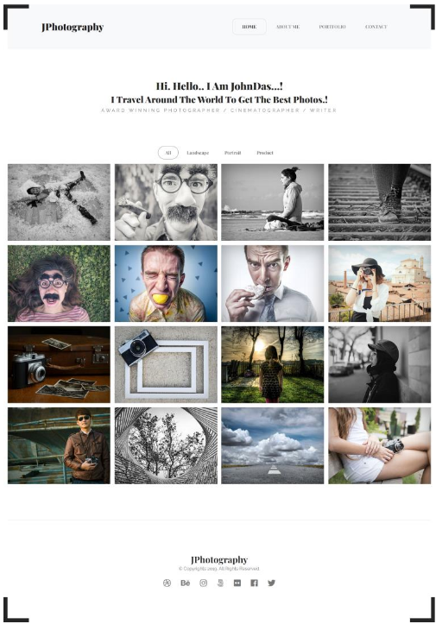

Gambar . Soal Praktikum

## Source Code

Tabel . Source Code Soal Praktikum

|  |  |
| --- | --- |
|  | <!DOCTYPE html> |
|  | <html lang="en"> |
|  | <head> |
|  | <meta charset="UTF-8"> |
|  | <meta http-equiv="X-UA-Compatible" content="IE=edge"> |
|  | <meta name="viewport" content="width=device-width, initial-scale=1.0"> |
|  | <title>Document</title> |
|  | <link rel="stylesheet" href="https://cdn.jsdelivr.net/npm/bootstrap@5.3.0-alpha3/dist/css/bootstrap.min.css"> |
|  | <style> |
|  | *, body { |
|  | list-style: none; |
|  | text-decoration: none; |
|  | box-sizing: border-box; |
|  | } |
|  | .header { |
|  | height: 90px; |
|  | } |
|  | .logo { |
|  | font-weight: 700; |
|  | } |
|  | .list{ |
|  | text-decoration: none; |
|  | font-weight: 600; |
|  | cursor: pointer; |
|  | } |
|  | h2 { |
|  | font-weight: 700; |
|  | } |
|  | .desc { |
|  | font-weight: 400; |
|  | letter-spacing: 3px; |
|  | color: #666; |
|  | } |
|  | p { |
|  | font-weight: 400; |
|  | color: #666; |
|  | } |
|  | .active1 { |
|  | border: solid 1px #666; |
|  | border-radius: 8px; |
|  | } |
|  | .carousel { |
|  | height: 55vh; |
|  | } |
|  | .active2 { |
|  | border: solid 1px black; |
|  | border-radius: 50px; |
|  | } |
|  | .bottom { |
|  | height: 350px; |
|  | } |
|  | .borders div { |
|  | z-index: 9999; |
|  | pointer-events: none; |
|  | background-color: transparent; |
|  | border-color: #252525; |
|  | border-style: solid; |
|  | height: 100px; |
|  | position: fixed; |
|  | width: 100px; |
|  | } |
|  | .brTR { |
|  | border-width: 10px 10px 0 0; |
|  | right: 0; |
|  | top: 0; |
|  | } |
|  | .brTL { |
|  | border-width: 10px 0 0 10px; |
|  | top: 0; |
|  | left: 0; |
|  | } |
|  | .brBL { |
|  | border-width: 0 0 10px 10px; |
|  | bottom: 0; |
|  | left: 0; |
|  | } |
|  | .brBR { |
|  | border-width: 0 10px 10px 0; |
|  | bottom: 0; |
|  | right: 0; |
|  | } |
|  | .icon { |
|  | color: #666; |
|  | font-size: 1.7rem; |
|  | } |
|  |  |
|  | /* *Gallery Styles* */ |
|  | .gallery-container { |
|  | max-width: 1200px; |
|  | margin: 0 auto; |
|  | padding: 20px; |
|  | } |
|  |  |
|  | .gallery-row { |
|  | display: flex; |
|  | justify-content: center; |
|  | gap: 15px; |
|  | margin-bottom: 15px; |
|  | flex-wrap: wrap; |
|  | } |
|  |  |
|  | .gallery-item { |
|  | transition: transform 0.3s ease; |
|  | } |
|  |  |
|  | .gallery-item:hover { |
|  | transform: scale(1.05); |
|  | } |
|  |  |
|  | .gallery-item img { |
|  | width: 200px; |
|  | height: 200px; |
|  | object-fit: cover; |
|  | box-shadow: 0 4px 8px rgba(0,0,0,0.1); |
|  | } |
|  |  |
|  | .category-section { |
|  | display: none; |
|  | } |
|  |  |
|  | .category-section.active { |
|  | display: block; |
|  | } |
|  |  |
|  | .filter-btn { |
|  | transition: all 0.3s ease; |
|  | } |
|  |  |
|  | .filter-btn:hover { |
|  | background-color: #f8f9fa; |
|  | } |
|  | </style> |
|  | <link rel="stylesheet" href="https://cdnjs.cloudflare.com/ajax/libs/font-awesome/6.4.0/css/all.min.css" integrity="sha512-iecdLmaskl7CVkqkXNQ/ZH/XLlvWZOJyj7Yy7tcenmpD1ypASozpmT/E0iPtmFIB46ZmdtAc9eNBvH0H/ZpiBw==" crossorigin="anonymous" referrerpolicy="no-referrer" /> |
|  | </head> |
|  | <body> |
|  | <div class="row header" style="background-color: #F8F9FB;"> |
|  | <div class="col-4 d-flex justify-content-center align-items-center"> |
|  | <h1 class="text-center logo" style="font-family:Cambria, Cochin, Georgia, Times, 'Times New Roman', serif">JPhotography</h1> |
|  | </div> |
|  | <div class="col-2"></div> |
|  | <div class="col-6 d-flex align-items-center justify-content-center"> |
|  | <nav> |
|  | <ul class="d-flex mt-3"> |
|  | <li><a class="px-4 py-2 list text-dark active1" href="" style="font-family: 'Playfair Display', serif;">HOME</a></li> |
|  | <li><a class="px-4 py-2 list" href="" style="font-family: 'Playfair Display', serif; color: #666;">ABOUT ME</a></li> |
|  | <li><a class="px-4 py-2 list" href="" style="font-family: 'Playfair Display', serif;color: #666;">PORTFOLIO</a></li> |
|  | <li><a class="px-4 py-2 list" href="" style="font-family: 'Playfair Display', serif;color: #666;">CONTACT</a></li> |
|  | </ul> |
|  | </nav> |
|  | </div> |
|  | </div> |
|  | <div class="row carousel"> |
|  | <div class="col d-flex flex-column justify-content-center align-items-center"> |
|  | <h2 style="font-family: 'Playfair Display', serif;">Hi. Hello.. I Am JohnDas...!</h2> |
|  | <h2 style="font-family: 'Playfair Display', serif;">I Travel Around The World To Get The Best Photos..!</h2> |
|  | <p class="desc">AWARD WINNING PHOTOGRAPHER / CINEMATOGRAPHER / WRITER</p> |
|  | </div> |
|  | </div> |
|  |  |
|  | <section class="borders"> |
|  | <div class="brTR"></div> |
|  | <div class="brTL"></div> |
|  | <div class="brBL"></div> |
|  | <div class="brBR"></div> |
|  | </section> |
|  |  |
|  | <div class="row container-fluid"> |
|  | <div class="col d-flex align-items-center justify-content-center" style="font-family: 'Playfair Display', serif;"> |
|  | <ul class="d-flex mt-3"> |
|  | <li><a class="px-4 py-2 list filter-btn active2" href="#" data-category="all" style="color: #666;">All</a></li> |
|  | <li><a class="px-4 py-2 list filter-btn" href="#" data-category="landscape" style="color: #666;">Landscape</a></li> |
|  | <li><a class="px-4 py-2 list filter-btn" href="#" data-category="portrait" style="color: #666;">Portrait</a></li> |
|  | <li><a class="px-4 py-2 list filter-btn" href="#" data-category="product" style="color: #666;">Product</a></li> |
|  | </ul> |
|  | </div> |
|  | </div> |
|  | <div class="gallery-container"> |
|  | <div id="all-section" class="category-section active"> |
|  | <div class="gallery-row"> |
|  | <div class="gallery-item"><img src="KTB1.jpg" alt="gambar 1"></div> |
|  | <div class="gallery-item"><img src="KTB2.jpg" alt="gambar 2"></div> |
|  | <div class="gallery-item"><img src="KTB3.jpg" alt="gambar 3"></div> |
|  | <div class="gallery-item"><img src="KTB5.jpg" alt="gambar 4"></div> |
|  | </div> |
|  | <div class="gallery-row"> |
|  | <div class="gallery-item"><img src="KTB4.png" alt="gambar 5"></div> |
|  | <div class="gallery-item"><img src="KTB7.jpg" alt="gambar 6"></div> |
|  | <div class="gallery-item"><img src="KTB8.jpg" alt="gambar 7"></div> |
|  | <div class="gallery-item"><img src="KTB6.png" alt="gambar 8"></div> |
|  | </div> |
|  | <div class="gallery-row"> |
|  | <div class="gallery-item"><img src="KTB10.jpg" alt="gambar 9"></div> |
|  | <div class="gallery-item"><img src="KTB11.jpg" alt="gambar 10"></div> |
|  | <div class="gallery-item"><img src="KTB12.png" alt="gambar 11"></div> |
|  | <div class="gallery-item"><img src="KTB13.jpg" alt="gambar 12"></div> |
|  | </div> |
|  | <div class="gallery-row"> |
|  | <div class="gallery-item"><img src="KTB14.jpg" alt="gambar 13"></div> |
|  | <div class="gallery-item"><img src="KTB15.jpg" alt="gambar 14"></div> |
|  | <div class="gallery-item"><img src="KTB16.jpg" alt="gambar 15"></div> |
|  | <div class="gallery-item"><img src="KTB17.jpg" alt="gambar 16"></div> |
|  | </div> |
|  | </div> |
|  | <div id="landscape-section" class="category-section"> |
|  | <div class="gallery-row"> |
|  | <div class="gallery-item"><img src="KTB3.jpg" alt="Landscape 1"></div> |
|  | <div class="gallery-item"><img src="KTB7.jpg" alt="Landscape 2"></div> |
|  | <div class="gallery-item"><img src="KTB11.jpg" alt="Landscape 3"></div> |
|  | <div class="gallery-item"><img src="KTB15.jpg" alt="Landscape 4"></div> |
|  | </div> |
|  | <div class="gallery-row"> |
|  | <div class="gallery-item"><img src="KTB1.jpg" alt="Landscape 5"></div> |
|  | <div class="gallery-item"><img src="KTB8.jpg" alt="Landscape 6"></div> |
|  | <div class="gallery-item"><img src="KTB13.jpg" alt="Landscape 7"></div> |
|  | <div class="gallery-item"><img src="KTB17.jpg" alt="Landscape 8"></div> |
|  | </div> |
|  | </div> |
|  | <div id="portrait-section" class="category-section"> |
|  | <div class="gallery-row"> |
|  | <div class="gallery-item"><img src="KTB2.jpg" alt="Portrait 1"></div> |
|  | <div class="gallery-item"><img src="KTB6.png" alt="Portrait 2"></div> |
|  | <div class="gallery-item"><img src="KTB10.jpg" alt="Portrait 3"></div> |
|  | <div class="gallery-item"><img src="KTB14.jpg" alt="Portrait 4"></div> |
|  | </div> |
|  | <div class="gallery-row"> |
|  | <div class="gallery-item"><img src="KTB4.png" alt="Portrait 5"></div> |
|  | <div class="gallery-item"><img src="KTB12.png" alt="Portrait 6"></div> |
|  | <div class="gallery-item"><img src="KTB16.jpg" alt="Portrait 7"></div> |
|  | <div class="gallery-item"><img src="KTB5.jpg" alt="Portrait 8"></div> |
|  | </div> |
|  | </div> |
|  | <div id="product-section" class="category-section"> |
|  | <div class="gallery-row"> |
|  | <div class="gallery-item"><img src="KTB15.jpg" alt="Product 1"></div> |
|  | <div class="gallery-item"><img src="KTB1.jpg" alt="Product 2"></div> |
|  | <div class="gallery-item"><img src="KTB11.jpg" alt="Product 3"></div> |
|  | <div class="gallery-item"><img src="KTB3.jpg" alt="Product 4"></div> |
|  | </div> |
|  | <div class="gallery-row"> |
|  | <div class="gallery-item"><img src="KTB7.jpg" alt="Product 5"></div> |
|  | <div class="gallery-item"><img src="KTB15.jpg" alt="Product 6"></div> |
|  | <div class="gallery-item"><img src="KTB13.jpg" alt="Product 7"></div> |
|  | <div class="gallery-item"><img src="KTB17.jpg" alt="Product 8"></div> |
|  | </div> |
|  | </div> |
|  | </div> |
|  | <div class="row bottom"> |
|  | <div class="col d-flex flex-column align-items-center justify-content-center"> |
|  | <h1 class="logo" style="font-family: Cambria, Cochin, Georgia, Times, 'Times New Roman', serif;">JPhotography</h1> |
|  | <p>&copy; Copyrights 2019 All Rights Reserved</p> |
|  | <div class="icon"> |
|  | <i class="fa-brands fa-dribbble pe-5"></i> |
|  | <i class="fa-brands fa-behance pe-5"></i> |
|  | <i class="fa-brands fa-instagram pe-5"></i> |
|  | <i class="fa-brands fa-500px pe-5"></i> |
|  | <i class="fa-brands fa-flickr pe-5"></i> |
|  | <i class="fa-brands fa-square-facebook pe-5"></i> |
|  | <i class="fa-brands fa-twitter pe-5"></i> |
|  | </div> |
|  | </div> |
|  | </div> |
|  | <script> |
|  | document.addEventListener('DOMContentLoaded', function() { |
|  | const filterButtons = document.querySelectorAll('.filter-btn'); |
|  | const sections = document.querySelectorAll('.category-section'); |
|  |  |
|  | filterButtons.forEach(button => { |
|  | button.addEventListener('click', function(e) { |
|  | e.preventDefault(); |
|  | filterButtons.forEach(btn => btn.classList.remove('active2')); |
|  | this.classList.add('active2'); |
|  | sections.forEach(section => section.classList.remove('active')); |
|  |  |
|  | const category = this.getAttribute('data-category'); |
|  | const targetSection = document.getElementById(category + '-section'); |
|  | if (targetSection) { |
|  | targetSection.classList.add('active'); |
|  | } |
|  | }); |
|  | }); |
|  | }); |
|  | </script> |
|  | <script src="https://cdn.jsdelivr.net/npm/@popperjs/core@2.11.7/dist/umd/popper.min.js" integrity="sha384-zYPOMqeu1DAVkHiLqWBUTcbYfZ8osu1Nd6Z89ify25QV9guujx43ITvfi12/QExE" crossorigin="anonymous"></script> |
|  | <script src="https://cdn.jsdelivr.net/npm/bootstrap@5.3.0-alpha3/dist/js/bootstrap.min.js" integrity="sha384-Y4oOpwW3duJdCWv5ly8SCFYWqFDsfob/3GkgExXKV4idmbt98QcxXYs9UoXAB7BZ" crossorigin="anonymous"></script> |
|  | </body> |
|  | </html> |

## Output

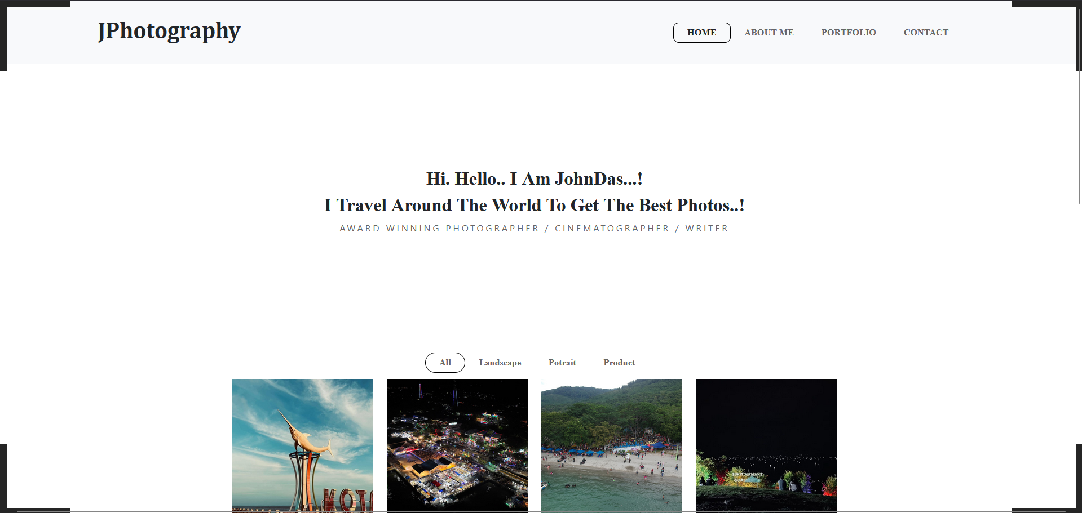

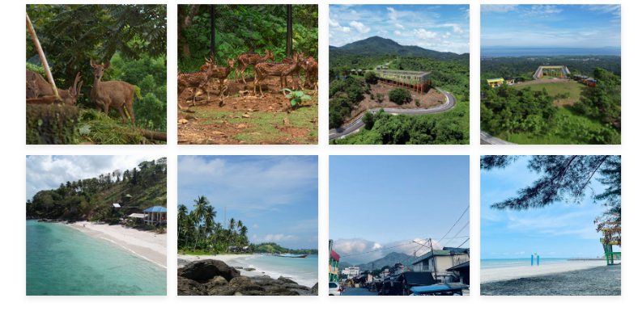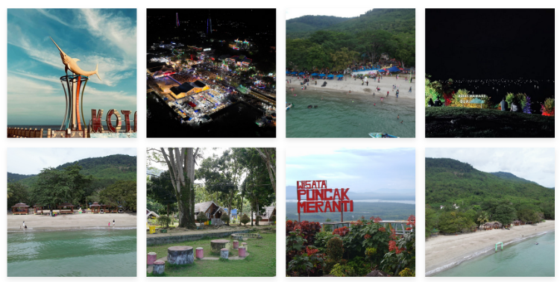



Gambar . Output Source Code

## Pembahasan

1. <!DOCTYPE html> – Deklarasi tipe dokumen HTML5
2. <html lang="en"> – Tag pembuka dokumen HTML dengan bahasa Inggris
3. <head> – Tag pembuka untuk bagian kepala dokumen HTML
4. <meta charset="UTF-8"> – Meta tag untuk encoding karakter UTF-8
5. <meta http-equiv="X-UA-Compatible" content="IE=edge"> – Meta tag untuk kompatibilitas Internet Explorer
6. <meta name="viewport" content="width=device-width, initial-scale=1.0"> – Meta tag untuk responsive design
7. <title>Document</title> – Judul halaman web yang tampil di tab browser
8. <link rel="stylesheet" href="https://cdn.jsdelivr.net/npm/bootstrap@5.3.0-alpha3/dist/css/bootstrap.min.css"> – Link ke Bootstrap CSS framework
9. <style> – Tag pembuka untuk mendefinisikan gaya CSS internal
10. *, body { – Selector universal dan body untuk reset style
11. list-style: none; – Menghilangkan bullet point pada list
12. text-decoration: none; – Menghilangkan underline pada link
13. box-sizing: border-box; – Mengatur box model menjadi border-box
14. } – Penutup deklarasi CSS
15. .header { – Selector class untuk elemen header
16. height: 90px; – Mengatur tinggi header 90 pixel
17. } – Penutup deklarasi CSS header
18. .logo { – Selector class untuk elemen logo
19. font-weight: 700; – Mengatur ketebalan font menjadi bold (700)
20. } – Penutup deklarasi CSS logo
21. .list{ – Selector class untuk elemen list navigasi
22. text-decoration: none; – Menghilangkan underline
23. font-weight: 600; – Mengatur ketebalan font semi-bold
24. cursor: pointer; – Mengubah kursor menjadi pointer saat hover
25. } – Penutup deklarasi CSS list
26. h2 { – Selector untuk semua elemen h2
27. font-weight: 700; – Mengatur ketebalan font h2 menjadi bold
28. } – Penutup deklarasi CSS h2
29. .desc { – Selector class untuk elemen deskripsi
30. font-weight: 400; – Mengatur ketebalan font normal
31. letter-spacing: 3px; – Mengatur jarak antar huruf 3 pixel
32. color: #666; – Mengatur warna teks abu-abu
33. } – Penutup deklarasi CSS desc
34. p { – Selector untuk semua elemen paragraf
35. font-weight: 400; – Mengatur ketebalan font normal
36. color: #666; – Mengatur warna teks abu-abu
37. } – Penutup deklarasi CSS paragraf
38. .active1 { – Selector class untuk menu navigasi aktif
39. border: solid 1px #666; – Border solid 1px dengan warna abu-abu
40. border-radius: 8px; – Membuat sudut rounded 8px
41. } – Penutup deklarasi CSS active1
42. .carousel { – Selector class untuk area carousel
43. height: 55vh; – Mengatur tinggi 55% dari viewport height
44. } – Penutup deklarasi CSS carousel
45. .active2 { – Selector class untuk filter button aktif
46. border: solid 1px black; – Border solid 1px hitam
47. border-radius: 50px; – Membuat sudut rounded 50px (oval)
48. } – Penutup deklarasi CSS active2
49. .bottom { – Selector class untuk bagian footer
50. height: 350px; – Mengatur tinggi footer 350px
51. } – Penutup deklarasi CSS bottom
52. .borders div { – Selector untuk div dalam elemen borders
53. z-index: 9999; – Mengatur layer paling atas
54. pointer-events: none; – Menonaktifkan interaksi mouse
55. background-color: transparent; – Background transparan
56. border-color: #252525; – Warna border gelap
57. border-style: solid; – Style border solid
58. height: 100px; – Tinggi 100px
59. position: fixed; – Posisi fixed (tetap di layar)
60. width: 100px; – Lebar 100px
61. } – Penutup deklarasi CSS borders div
62. .brTR { – Selector untuk border top-right
63. border-width: 10px 10px 0 0; – Border atas dan kanan 10px
64. right: 0; – Posisi di kanan layar
65. top: 0; – Posisi di atas layar
66. } – Penutup deklarasi CSS brTR
67. .brTL { – Selector untuk border top-left
68. border-width: 10px 0 0 10px; – Border atas dan kiri 10px
69. top: 0; – Posisi di atas layar
70. left: 0; – Posisi di kiri layar
71. } – Penutup deklarasi CSS brTL
72. .brBL { – Selector untuk border bottom-left
73. border-width: 0 0 10px 10px; – Border bawah dan kiri 10px
74. bottom: 0; – Posisi di bawah layar
75. left: 0; – Posisi di kiri layar
76. } – Penutup deklarasi CSS brBL
77. .brBR { – Selector untuk border bottom-right
78. border-width: 0 10px 10px 0; – Border bawah dan kanan 10px
79. bottom: 0; – Posisi di bawah layar
80. right: 0; – Posisi di kanan layar
81. } – Penutup deklarasi CSS brBR
82. .icon { – Selector class untuk ikon social media
83. color: #666; – Warna ikon abu-abu
84. font-size: 1.7rem; – Ukuran font 1.7rem
85. } – Penutup deklarasi CSS icon
86. /* Gallery Styles */ – Komentar CSS untuk bagian gallery
87. .gallery-container { – Selector untuk container gallery
88. max-width: 1200px; – Lebar maksimum 1200px
89. margin: 0 auto; – Margin otomatis untuk center alignment
90. padding: 20px; – Padding 20px di semua sisi
91. } – Penutup deklarasi CSS gallery-container
92. .gallery-row { – Selector untuk baris gallery
93. display: flex; – Menggunakan flexbox layout
94. justify-content: center; – Konten center horizontal
95. gap: 15px; – Jarak antar item 15px
96. margin-bottom: 15px; – Margin bawah 15px
97. flex-wrap: wrap; – Item dapat wrap ke baris baru
98. } – Penutup deklarasi CSS gallery-row
99. .gallery-item { – Selector untuk item gallery
100. transition: transform 0.3s ease; – Animasi transform 0.3 detik
101. } – Penutup deklarasi CSS gallery-item
102. .gallery-item:hover { – Selector hover untuk gallery item
103. transform: scale(1.05); – Memperbesar 5% saat hover
104. } – Penutup deklarasi CSS gallery-item hover
105. .gallery-item img { – Selector untuk gambar dalam gallery item
106. width: 200px; – Lebar gambar 200px
107. height: 200px; – Tinggi gambar 200px
108. object-fit: cover; – Gambar memenuhi area tanpa distorsi
109. box-shadow: 0 4px 8px rgba(0,0,0,0.1); – Bayangan dengan opacity 0.1
110. } – Penutup deklarasi CSS gallery-item img
111. .category-section { – Selector untuk section kategori
112. display: none; – Sembunyikan section secara default
113. } – Penutup deklarasi CSS category-section
114. .category-section.active { – Selector untuk section kategori aktif
115. display: block; – Tampilkan section yang aktif
116. } – Penutup deklarasi CSS category-section active
117. .filter-btn { – Selector untuk tombol filter
118. transition: all 0.3s ease; – Animasi semua properti 0.3 detik
119. } – Penutup deklarasi CSS filter-btn
120. .filter-btn:hover { – Selector hover untuk tombol filter
121. background-color: #f8f9fa; – Background abu-abu terang saat hover
122. } – Penutup deklarasi CSS filter-btn hover
123. </style> – Tag penutup CSS internal
124. <link rel="stylesheet" href="https://cdnjs.cloudflare.com/ajax/libs/font-awesome/6.4.0/css/all.min.css" integrity="sha512-iecdLmaskl7CVkqkXNQ/ZH/XLlvWZOJyj7Yy7tcenmpD1ypASozpmT/E0iPtmFIB46ZmdtAc9eNBvH0H/ZpiBw==" crossorigin="anonymous" referrerpolicy="no-referrer" /> – Link ke Font Awesome untuk ikon
125. </head> – Tag penutup head
126. <body> – Tag pembuka body dokumen
127. <div class="row header" style="background-color: #F8F9FB;"> – Div header dengan background abu-abu terang
128. <div class="col-4 d-flex justify-content-center align-items-center"> – Kolom 4/12 dengan flexbox center
129. <h1 class="text-center logo" style="font-family:Cambria, Cochin, Georgia, Times, 'Times New Roman', serif">JPhotography</h1> – Header logo dengan font serif
130. </div> – Penutup div kolom logo
131. <div class="col-2"></div> – Kolom kosong untuk spacing
132. <div class="col-6 d-flex align-items-center justify-content-center"> – Kolom 6/12 untuk navigation
133. <nav> – Tag navigasi
134. <ul class="d-flex mt-3"> – List navigasi dengan flexbox dan margin top
135. <li><a class="px-4 py-2 list text-dark active1" href="" style="font-family: 'Playfair Display', serif;">HOME</a></li> – Link HOME dengan class active1
136. <li><a class="px-4 py-2 list" href="" style="font-family: 'Playfair Display', serif; color: #666;">ABOUT ME</a></li> – Link ABOUT ME
137. <li><a class="px-4 py-2 list" href="" style="font-family: 'Playfair Display', serif;color: #666;">PORTFOLIO</a></li> – Link PORTFOLIO
138. <li><a class="px-4 py-2 list" href="" style="font-family: 'Playfair Display', serif;color: #666;">CONTACT</a></li> – Link CONTACT
139. </ul> – Penutup list navigasi
140. </nav> – Penutup navigasi
141. </div> – Penutup div kolom navigasi
142. </div> – Penutup div header
143. <div class="row carousel"> – Div hero section dengan class carousel
144. <div class="col d-flex flex-column justify-content-center align-items-center"> – Kolom dengan flexbox center vertikal dan horizontal
145. <h2 style="font-family: 'Playfair Display', serif;">Hi. Hello.. I Am JohnDas...!</h2> – Header perkenalan pertama
146. <h2 style="font-family: 'Playfair Display', serif;">I Travel Around The World To Get The Best Photos..!</h2> – Header perkenalan kedua
147. <p class="desc">AWARD WINNING PHOTOGRAPHER / CINEMATOGRAPHER / WRITER</p> – Paragraf deskripsi profesi
148. </div> – Penutup div kolom hero
149. </div> – Penutup div hero section
150. <section class="borders"> – Section untuk dekorasi border
151. <div class="brTR"></div> – Div border top-right
152. <div class="brTL"></div> – Div border top-left
153. <div class="brBL"></div> – Div border bottom-left
154. <div class="brBR"></div> – Div border bottom-right
155. </section> – Penutup section borders
156. <div class="row container-fluid"> – Div row dengan container fluid
157. <div class="col d-flex align-items-center justify-content-center" style="font-family: 'Playfair Display', serif;"> – Kolom dengan flexbox center
158. <ul class="d-flex mt-3"> – List filter dengan flexbox
159. <li><a class="px-4 py-2 list filter-btn active2" href="#" data-category="all" style="color: #666;">All</a></li> – Filter "All" dengan class active2
160. <li><a class="px-4 py-2 list filter-btn" href="#" data-category="landscape" style="color: #666;">Landscape</a></li> – Filter "Landscape"
161. <li><a class="px-4 py-2 list filter-btn" href="#" data-category="portrait" style="color: #666;">Portrait</a></li> – Filter "Portrait"
162. <li><a class="px-4 py-2 list filter-btn" href="#" data-category="product" style="color: #666;">Product</a></li> – Filter "Product"
163. </ul> – Penutup list filter
164. </div> – Penutup div kolom filter
165. </div> – Penutup div row filter
166. <div class="gallery-container"> – Container utama gallery
167. <div id="all-section" class="category-section active"> – Section "All" dengan class active
168. <div class="gallery-row"> – Baris pertama gallery
169. <div class="gallery-item"><img src="KTB1.jpg" alt="gambar 1"></div> – Item gallery dengan gambar KTB1.jpg
170. <div class="gallery-item"><img src="KTB2.jpg" alt="gambar 2"></div> – Item gallery dengan gambar KTB2.jpg
171. <div class="gallery-item"><img src="KTB3.jpg" alt="gambar 3"></div> – Item gallery dengan gambar KTB3.jpg
172. <div class="gallery-item"><img src="KTB5.jpg" alt="gambar 4"></div> – Item gallery dengan gambar KTB5.jpg
173. </div> – Penutup baris pertama gallery
174. <div class="gallery-row"> – Baris kedua gallery
175. <div class="gallery-item"><img src="KTB4.png" alt="gambar 5"></div> – Item gallery dengan gambar KTB4.png
176. <div class="gallery-item"><img src="KTB7.jpg" alt="gambar 6"></div> – Item gallery dengan gambar KTB7.jpg
177. <div class="gallery-item"><img src="KTB8.jpg" alt="gambar 7"></div> – Item gallery dengan gambar KTB8.jpg
178. <div class="gallery-item"><img src="KTB6.png" alt="gambar 8"></div> – Item gallery dengan gambar KTB6.png
179. </div> – Penutup baris kedua gallery
180. <div class="gallery-row"> – Baris ketiga gallery
181. <div class="gallery-item"><img src="KTB10.jpg" alt="gambar 9"></div> – Item gallery dengan gambar KTB10.jpg
182. <div class="gallery-item"><img src="KTB11.jpg" alt="gambar 10"></div> – Item gallery dengan gambar KTB11.jpg
183. <div class="gallery-item"><img src="KTB12.png" alt="gambar 11"></div> – Item gallery dengan gambar KTB12.png
184. <div class="gallery-item"><img src="KTB13.jpg" alt="gambar 12"></div> – Item gallery dengan gambar KTB13.jpg
185. </div> – Penutup baris ketiga gallery
186. <div class="gallery-row"> – Baris keempat gallery
187. <div class="gallery-item"><img src="KTB14.jpg" alt="gambar 13"></div> – Item gallery dengan gambar KTB14.jpg
188. <div class="gallery-item"><img src="KTB15.jpg" alt="gambar 14"></div> – Item gallery dengan gambar KTB15.jpg
189. <div class="gallery-item"><img src="KTB16.jpg" alt="gambar 15"></div> – Item gallery dengan gambar KTB16.jpg
190. <div class="gallery-item"><img src="KTB17.jpg" alt="gambar 16"></div> – Item gallery dengan gambar KTB17.jpg
191. </div> – Penutup baris keempat gallery
192. </div> – Penutup section "All"
193. <div id="landscape-section" class="category-section"> – Section "Landscape" (tersembunyi default)
194. <div class="gallery-row"> – Baris pertama landscape
195. <div class="gallery-item"><img src="KTB3.jpg" alt="Landscape 1"></div> – Item landscape 1
196. <div class="gallery-item"><img src="KTB7.jpg" alt="Landscape 2"></div> – Item landscape 2
197. <div class="gallery-item"><img src="KTB11.jpg" alt="Landscape 3"></div> – Item landscape 3
198. <div class="gallery-item"><img src="KTB15.jpg" alt="Landscape 4"></div> – Item landscape 4
199. </div> – Penutup baris pertama landscape
200. <div class="gallery-row"> – Baris kedua landscape
201. <div class="gallery-item"><img src="KTB1.jpg" alt="Landscape 5"></div> – Item landscape 5
202. <div class="gallery-item"><img src="KTB8.jpg" alt="Landscape 6"></div> – Item landscape 6
203. <div class="gallery-item"><img src="KTB13.jpg" alt="Landscape 7"></div> – Item landscape 7
204. <div class="gallery-item"><img src="KTB17.jpg" alt="Landscape 8"></div> – Item landscape 8
205. </div> – Penutup baris kedua landscape
206. </div> – Penutup section landscape
207. <div id="portrait-section" class="category-section"> – Section "Portrait" (tersembunyi default)
208. <div class="gallery-row"> – Baris pertama portrait
209. <div class="gallery-item"><img src="KTB2.jpg" alt="Portrait 1"></div> – Item portrait 1
210. <div class="gallery-item"><img src="KTB6.png" alt="Portrait 2"></div> – Item portrait 2
211. <div class="gallery-item"><img src="KTB10.jpg" alt="Portrait 3"></div> – Item portrait 3
212. <div class="gallery-item"><img src="KTB14.jpg" alt="Portrait 4"></div> – Item portrait 4
213. </div> – Penutup baris pertama portrait
214. <div class="gallery-row"> – Baris kedua portrait
215. <div class="gallery-item"><img src="KTB4.png" alt="Portrait 5"></div> – Item portrait 5
216. <div class="gallery-item"><img src="KTB12.png" alt="Portrait 6"></div> – Item portrait 6
217. <div class="gallery-item"><img src="KTB16.jpg" alt="Portrait 7"></div> – Item portrait 7
218. <div class="gallery-item"><img src="KTB5.jpg" alt="Portrait 8"></div> – Item portrait 8
219. </div> – Penutup baris kedua portrait
220. </div> – Penutup section portrait
221. <div id="product-section" class="category-section"> – Section "Product" (tersembunyi default)
222. <div class="gallery-row"> – Baris pertama product
223. <div class="gallery-item"><img src="KTB15.jpg" alt="Product 1"></div> – Item product 1
224. <div class="gallery-item"><img src="KTB1.jpg" alt="Product 2"></div> – Item product 2
225. <div class="gallery-item"><img src="KTB11.jpg" alt="Product 3"></div> – Item product 3
226. <div class="gallery-item"><img src="KTB3.jpg" alt="Product 4"></div> – Item product 4
227. </div> – Penutup baris pertama product
228. <div class="gallery-row"> – Baris kedua product
229. <div class="gallery-item"><img src="KTB7.jpg" alt="Product 5"></div> – Item product 5
230. <div class="gallery-item"><img src="KTB15.jpg" alt="Product 6"></div> – Item product 6
231. <div class="gallery-item"><img src="KTB13.jpg" alt="Product 7"></div> – Item product 7
232. <div class="gallery-item"><img src="KTB17.jpg" alt="Product 8"></div> – Item product 8
233. </div> – Penutup baris kedua product
234. </div> – Penutup section product
235. </div> – Penutup gallery container
236. <div class="row bottom"> – Div footer dengan class bottom
237. <div class="col d-flex flex-column align-items-center justify-content-center"> – Kolom dengan flexbox center vertikal
238. <h1 class="logo" style="font-family: Cambria, Cochin, Georgia, Times, 'Times New Roman', serif;">JPhotography</h1> – Logo di footer
239. <p>&copy; Copyrights 2019 All Rights Reserved</p> – Paragraf copyright
240. <div class="icon"> – Div container untuk ikon social media
241. <i class="fa-brands fa-dribbble pe-5"></i> – Ikon Dribbble dengan padding end 5
242. <i class="fa-brands fa-behance pe-5"></i> – Ikon Behance dengan padding end 5
243. <i class="fa-brands fa-instagram pe-5"></i> – Ikon Instagram dengan padding end 5
244. <i class="fa-brands fa-500px pe-5"></i> – Ikon 500px dengan padding end 5
245. <i class="fa-brands fa-flickr pe-5"></i> – Ikon Flickr dengan padding end 5
246. <i class="fa-brands fa-square-facebook pe-5"></i> – Ikon Facebook dengan padding end 5
247. <i class="fa-brands fa-twitter pe-5"></i> – Ikon Twitter dengan padding end 5
248. </div> – Penutup div ikon
249. </div> – Penutup div kolom footer
250. </div> – Penutup div row footer
251. <script> – Tag pembuka JavaScript
252. document.addEventListener('DOMContentLoaded', function() { – Event listener saat DOM selesai loading
253. const filterButtons = document.querySelectorAll('.filter-btn'); – Mengambil semua tombol filter
254. const sections = document.querySelectorAll('.category-section'); – Mengambil semua section kategori
255. filterButtons.forEach(button => { – Loop untuk setiap tombol filter
256. button.addEventListener('click', function(e) { – Event listener click untuk tombol
257. e.preventDefault(); – Mencegah default behavior link
258. filterButtons.forEach(btn => btn.classList.remove('active2')); – Menghapus class active2 dari semua tombol
259. this.classList.add('active2'); – Menambah class active2 ke tombol yang diklik
260. sections.forEach(section => section.classList.remove('active')); – Menghapus class active dari semua section
261. const category = this.getAttribute('data-category'); – Mengambil nilai data-category dari tombol
262. const targetSection = document.getElementById(category + '-section'); – Mencari section target berdasarkan kategori
263. if (targetSection) { – Kondisi if jika section target ditemukan
264. targetSection.classList.add('active'); – Menambah class active ke section target
265. } – Penutup kondisi if
266. }); – Penutup event listener click
267. }); – Penutup loop forEach tombol
268. }); – Penutup event listener DOMContentLoaded
269. </script> – Tag penutup JavaScript
270. <script src="https://cdn.jsdelivr.net/npm/@popperjs/core@2.11.7/dist/umd/popper.min.js" integrity="sha384-zYPOMqeu1DAVkHiLqWBUTcbYfZ8osu1Nd6Z89ify25QV9guujx43ITvfi12/QExE" crossorigin="anonymous"></script> – Script Popper.js untuk Bootstrap
271. <script src="https://cdn.jsdelivr.net/npm/bootstrap@5.3.0-alpha3/dist/js/bootstrap.min.js" integrity="sha384- Y4oOpwW3duJdCWv5ly8SCFYWqFDsfob/3GkgExXKV4idmbt98QcxXYs9UoXAB7BZ" crossorigin="anonymous"></script> – Script Bootstrap JavaScript
272. </body> – Tag penutup body
273. </html> – Tag penutup dokumen HTML

# GITHUB

<https://github.com/muh-ghazi32/Pemrograman-Web-1>